Eda İslam 2585081 07.11.2023
Yağmur Can 2637536 Tuesday Session
Assistant: Pierre Twizeyimana

EXPERIMENT II ANALYSIS OF SIMPLE ELECTRICAL CIRCUITS USING KIRCHHOFF’s and OHM’s LAWS
- Objective
In this experiment, we will learn what are the concepts of voltage and current dividers. We will understand the differences between combining resistors in parallel or series in circuits. In the prework, we used Kirchhoff’s current and voltage law, OHM’s Law, Superposition Principle to analyze the circuits in the experiment. We will understand the logic behind Wheatstone Bridge circuit. We will learn how to use voltage supplies, Function Generator, Multi-Meter, Digital Oscilloscope while we create circuit with DC and AC signals. We will learn the X-Y mode of Digital Oscilloscope, we examined different graphic types that changes according to circuit design. We used LTSpice for design the circuits and see the graphs before the experiment.
EQUIPMENT LIST:
- Power Supply
- Digital Oscilloscope
-Function\Arbitrary Waveform Generator
-Resistors (100Ω, 6 x 1kΩ, 3.3kΩ, 2 x 1.2kΩ, 6.8kΩ, 10k pot).
- Results

- Conclusions

Experimental Work 1:
What we used:
-Digital Oscilloscope
-Function\Arbitrary Waveform Generator
-Resistors (1kΩ, 3.3kΩ,6.8kΩ,4.7 kΩ,).
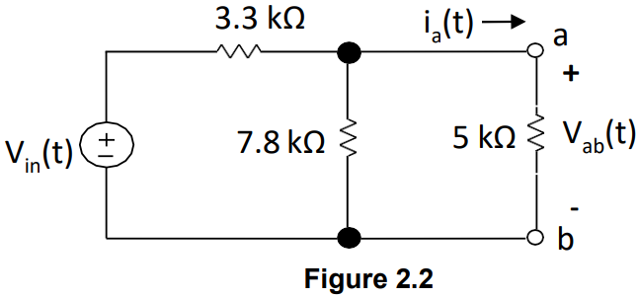
We started the experimental work by setting up the circuit of figure 2.2 from the prework manual.

By setting the function generator to High Z mode during the experiment, our set up was ready.
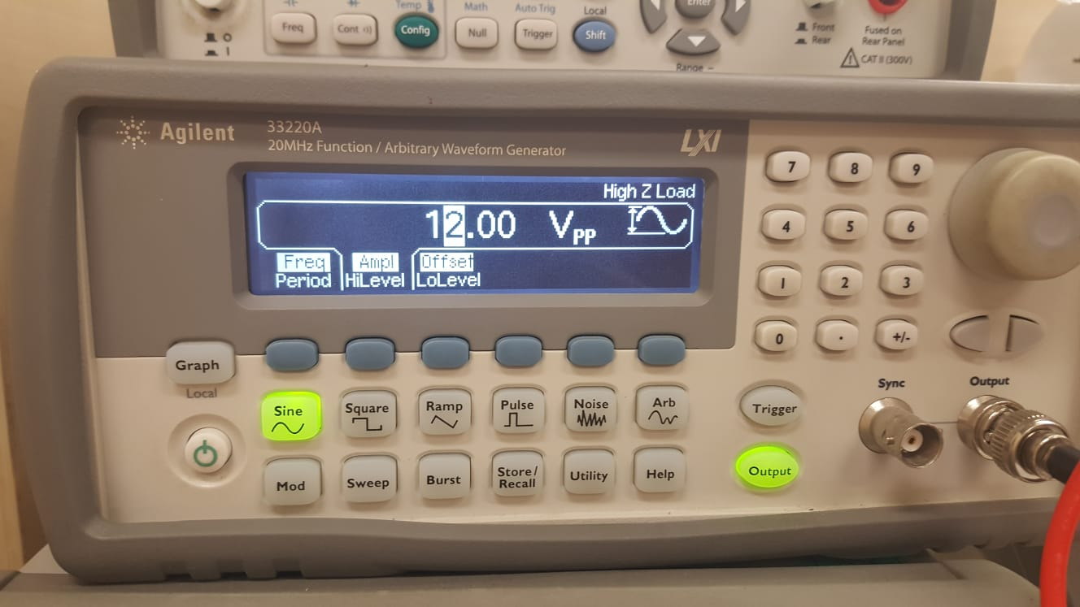
1: Experimental Work 1 (Function/Arbitrary Waveform Generator in Hz Mode)

- Without connecting voltage source to the circuit, we first measured the equivalent resistance, Rab.
Using the function generator as an AC voltage source we set Vin(t)=6sin (100 πt). Arranging function generator to 12Vpp and 50 Hz, we measured Vab,rms and Ia,rms values.

TABLE 1:
Rab Calculated from Prework 1.B(a) (kΩ) | Ia,rms Calculated from Prework 1.B(b) (A) | Rab Measured (kΩ) | Vab, rms Measured (V) | Ia,rms Measured (A)
3,046 | 0,096 |  | 1,81 | 0.00039
Rab measured değeri yok?

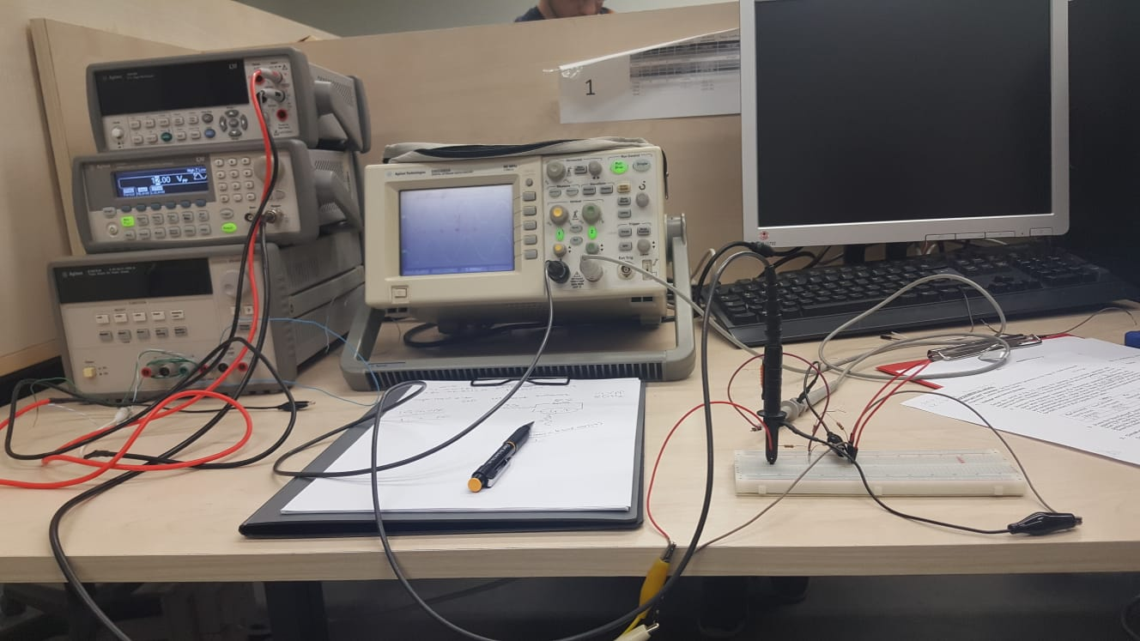
2:Experimental Work 1 (Circuit Design)

Connecting Channel 1 to the voltage source and Channel 2 to the 4.7 kΩ resistor, we plot the graph of the voltage source and the resistor on oscilloscope.
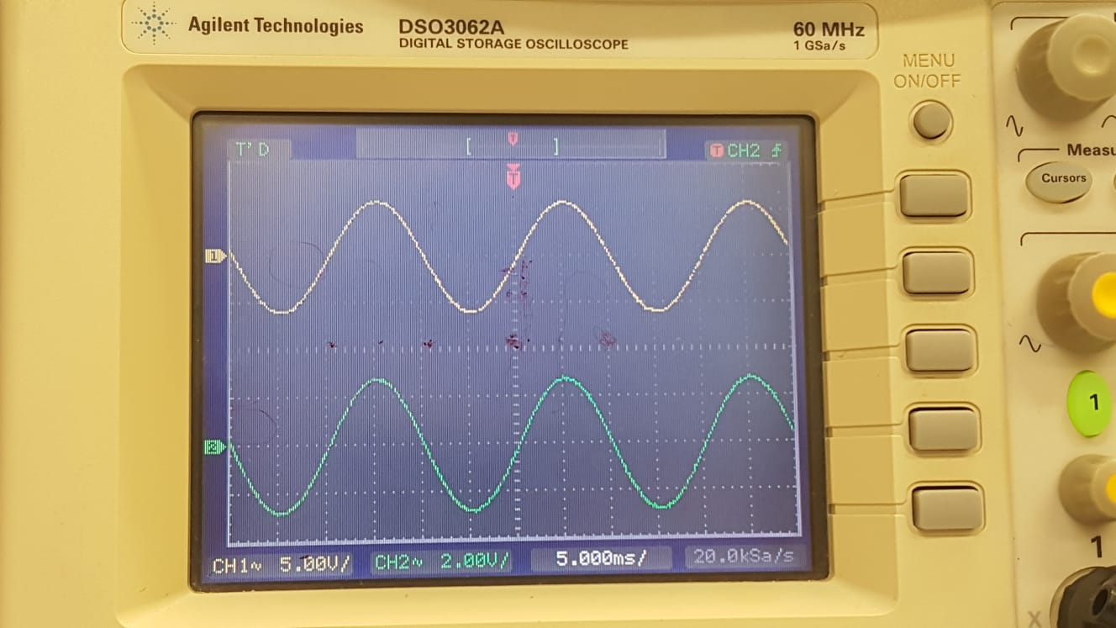
3: Experimental Work 1 (Digital Oscilloscopes)
- Changing the necessary settings on the oscilloscope, we plot the graph in X-Y mode. The graph
gives us the signal in Channel 2(Y) as a function of the signal in Channel 1(X).
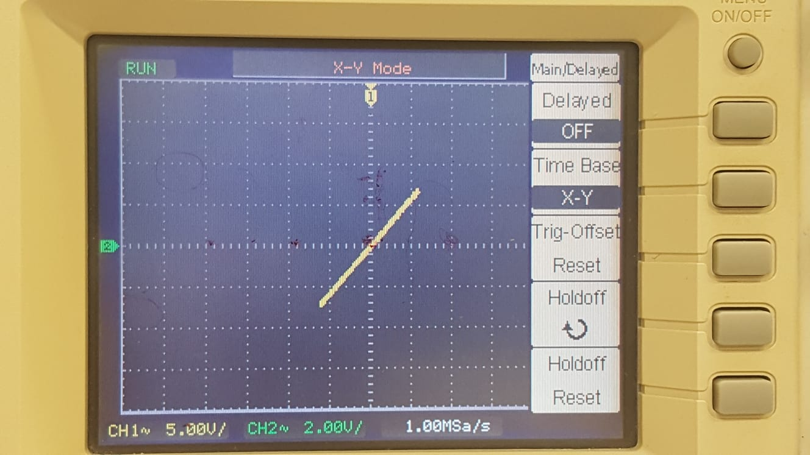
As we see in the graph signal of channel 2 and signal of channel 1 form into line, since both of the signal’s frequency is the same.
4: (Digital Oscilloscope in X-Y mode)

Experimental Work 2:
What we used:
- Power Supply
- Digital Oscilloscope
-Function\Arbitrary Waveform Generator
-Resistors (6 x 1kΩ).
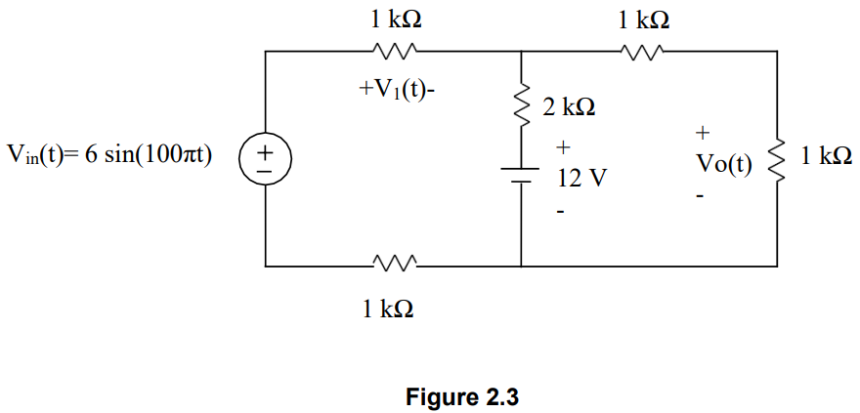
We started the experimental work by setting up the circuit of figure 2.3 from the prework manual.

- Using the same function generator and setting up the circuit we plotted the waveform of 3 cases on the oscilloscope.
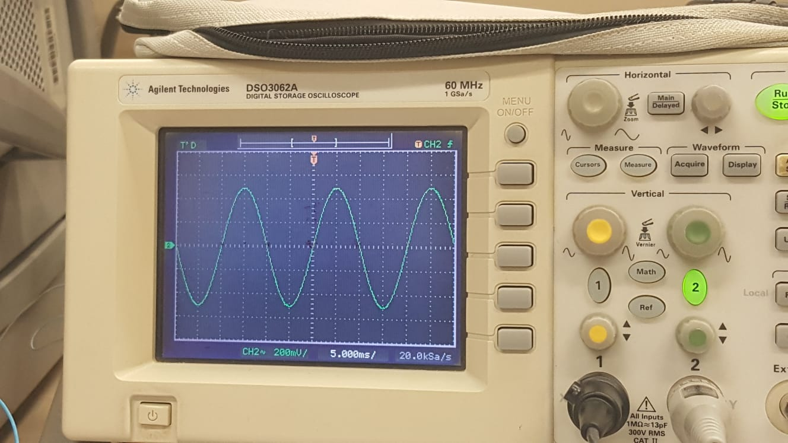
1) Vo(t) fluctuating in the waveform of sin(100πt) and Vmax=0.2 Volt.?
5: (i. When the 12V DC Power Supply is turned off)
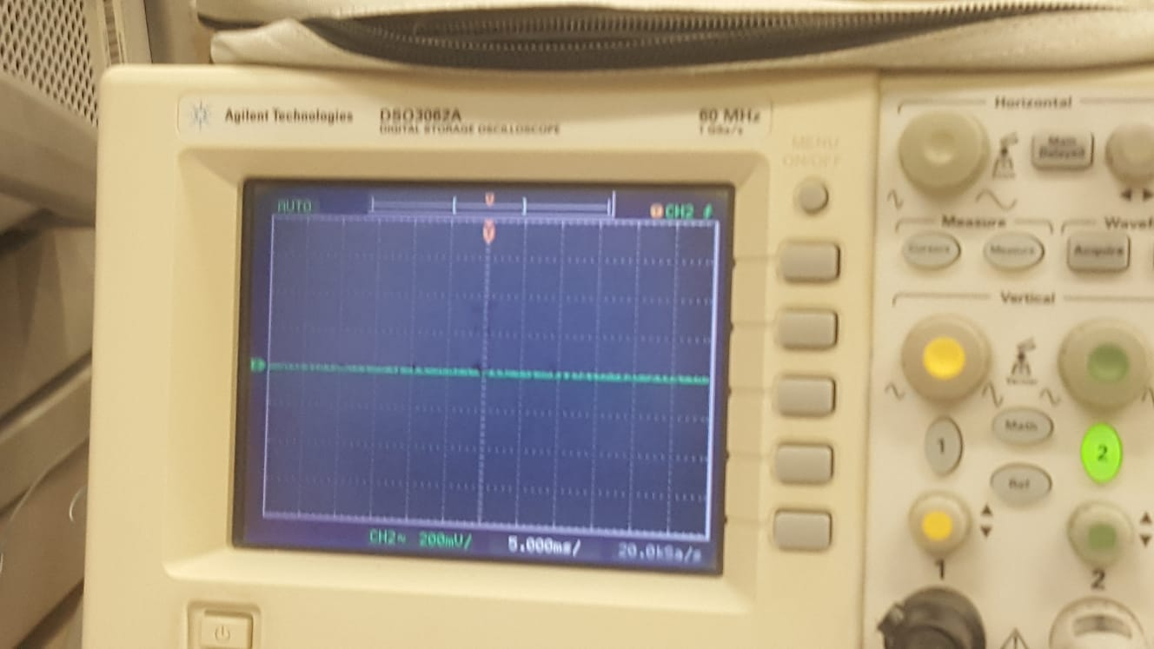
2) Vo(t)=0 because by killing the function generator Ch2 node is no longer connected to the ground. It is connected to the oscilloscope. This causes
6:(ii. When the Function Generator is turned off)

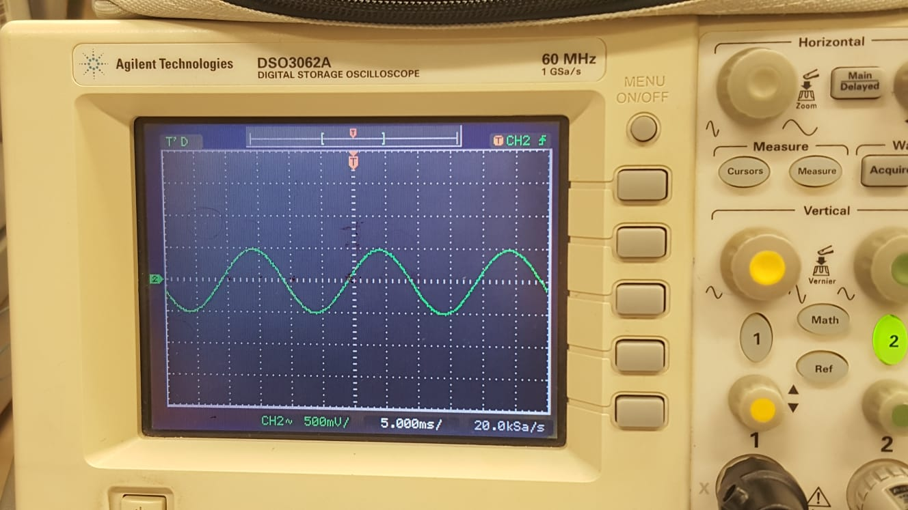
3)
7: (iii. When both the DC power supply and function generator are turned on)
The plots are consistent with the superposition principle. When both the AC and DC sources are turned on, the voltage between the nodes is the sum of the voltages when the other source is killed. We see that in the plot, the amplitude of the plot is higher when AC source is killed then when both of the sources are on. That is because when we add both waveform they balance each other. Of o kadar bilmiyom ki ne yaptğımızı
- Experimental Work 2 (When the connection between the first node and channel 1 is provided)

